Gábor KECSKÉS PhD. | 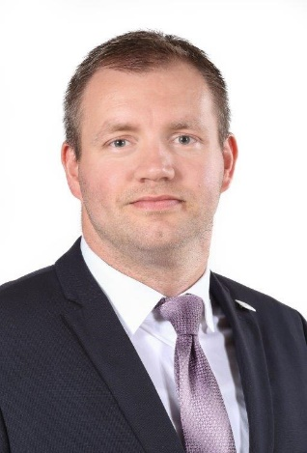

E-mail: kecskesg@ga.sze.hu

PROFESSIONAL EXPERIENCE

2021-
Member
Outer Space and Social Sciences Research Group
University of Public Service
https://osrg.uni-nke.hu/

2017-
Vice-dean
Széchenyi István University Deák Ferenc Faculty of Law and Political Sciences

2016-
Associate professor
Széchenyi István University Deák Ferenc Faculty of Law and Political Sciences

2006-
Research fellow
ELKH Centre for Social Sciences, Institute for Legal Studies

2012-2016
Secretary
Széchenyi István University, Postgraduate Doctoral School of Law and Political Sciences

2009-2017
Scientific Secretary
Hungarian Academy of Sciences, Centre for Social Sciences, Institute for Legal Studies

ACADEMIC ACTIVITIES

- Széchenyi István University Deák Ferenc Faculty of Law and Political Sciences
Public International Law, Nuclear Law, Environmental Law

- Budapest College of Management (2008-2009)
International Law

STUDIES

2014  2012 | The Hague Academy of International Law, Public International Law Session  PhD: The Liabilty for Environmental Damage in International Law (Széchenyi István University, summa cum laude)
2007 | International School of Nuclear Law (OECD Nuclear Energy Agency – Université de Montpellier), Montpellier, France, 2007 Session. Diploma of nuclear law.
2001-2006 | ELTE Faculty of Law and Political Sciences, Institute of Győr, J.D. (cum laude)

FIELDS OF RESEARCH

Public International law, Space Law, Nuclear law, International environmental law

SCIENTIFIC AWARDS

Environmental Scientific Youth Award of the Hungarian Academy of Sciences (2011)

PUPLIC OFFICES

- Academy of Young Researchers’, member (2020-)
- Hungarian Academy of Sciences, Committee for Law and Political Sciences, member (2021-)
- International Journal of Nuclear Law, member of the editorial board (2020-)
- National Scientific Students' Associations, Committee for Law and Political Sciences, vice-president (2020-)
- International Nuclear Law Association, member (2010)
- International Law Association, Hungarian Brench, member (2009-)

LANGUAGES

English – C1
German – B2
French – A1
Hungarian – mother tongue

